SIMATS ENGINEERING (SAVEETHA SCHOOL OF ENGINEERING)
Department of Computer Science and Engineering

ASSESSMENT TOOL 1 – Constraint-Based Problem Solving

Course Code: | CSA06 | Course Title: | Design and Analysis of Algorithms
CO Assessed: | CO5– Naturalization (BL5,BL6) | Assessment: | Assessment Tool 1 – Constraint Based Problem Solving
Weightage: | 30% of CIA | Total Marks: | 100
CO5 Statement: | Analyze computational problems using backtracking techniques and complexity classes such as P, NP, NP-Hard, and NP-Complete for combinatorial problem solving.
Student Name: | KAILASH M | Reg. No.: | 192524029
Section / Batch: | 2025 | Date: | 03/09/2026

Instructions to Students
- Answer the following question. Total Marks: 100.
- Apply backtracking techniques systematically for combinatorial problem solving.
- Clearly classify problems under P, NP, NP-Hard, and NP-Complete categories wherever required.
- Provide proper justification, state-space representation, and complexity analysis for all solutions.
- Neat presentation and logical explanation are mandatory.

Question Type | Focus Area | Questions
Constraint Based Problem Solving | Analyze combinatorial problems using backtracking and complexity classes such as P, NP, NP-Hard, and NPComplete. | Q1

SECTION A – CONSTRAINT-BASED PROBLEM SOLVING

Code of Conduct
I KAILASH M (192524029) certify that this submission is my original work and that I have adhered to the guidelines specified for this assessment. I understand that any violation of academic integrity rules will result in disciplinary action.
Signature of the Student: KAILASH M
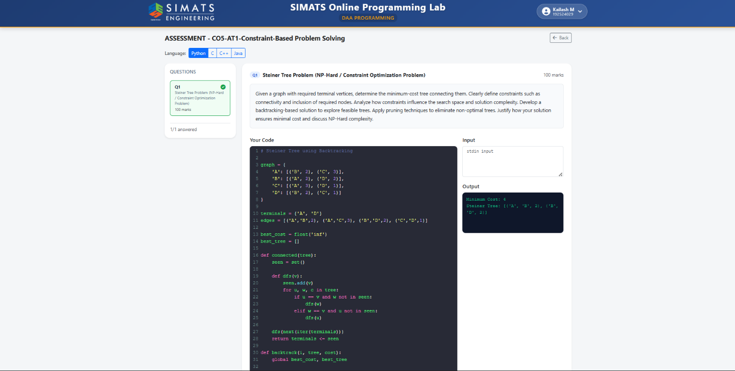

RUBRICS FOR CALCULATION

Criteria | Wt. | Level 4 – Exemplary | Level 3 –  Proficient | Level 2 –  Developing | Level 1 –  Beginning
Problem  Understanding | 25% | Clearly defines the problem and identifies all relevant constraints accurately | Identifies most constraints with minor gaps | Partial understandi ng;  misses key constraints | Fails to identify constraints correctly
Constraint Analysis | 25% | Analyzes constraints effectively and prioritizes them logically | Provides reasonable  analysis with some prioritizatio n | Limited analysis; weak prioritization | No meaningful analysis or prioritization
Solution  Development | 25% | Develops optimal and feasible solutions satisfying all constraints | Develops workable solutions with minor limitations | Solutions partially satisfy constraints | Solutions do not meet constraints
Application of  Concepts | 15% | Effectively applies appropriate concepts, methods, or tools | Applies concepts with minor errors | Limited application; requires guidance | Unable to apply relevant concepts
Justification | 10% | Provides strong justification for decisions with logical reasoning | Provides justification with some clarity | Weak or unclear  justification | No justification provided

Marks Evaluation:
Criteria | Wt. | Level 4 –  Exemplary | Level 3 –  Proficient | Level 2 –  Developing | Level 1 –  Beginning
Problem Understanding | 25%
Constraint Analysis | 25%
Solution Development | 25%
Application of Concepts | 15%
Justification | 10%
Total Marks (100):

Faculty In-charge | Course Coordinator | Head of Department
Name: | Name: | Name:
Signature: _______________ | Signature: _______________ | Signature: _______________
Date: ___________________ | Date: ___________________ | Date: ___________________

